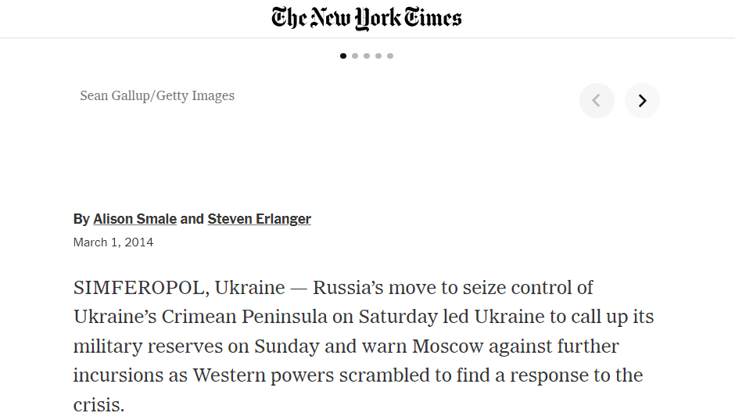[New York Times o Krymské invazi](https://www.nytimes.com/2014/03/02/world/europe/ukraine.html?smid=tw-bna&_r=0)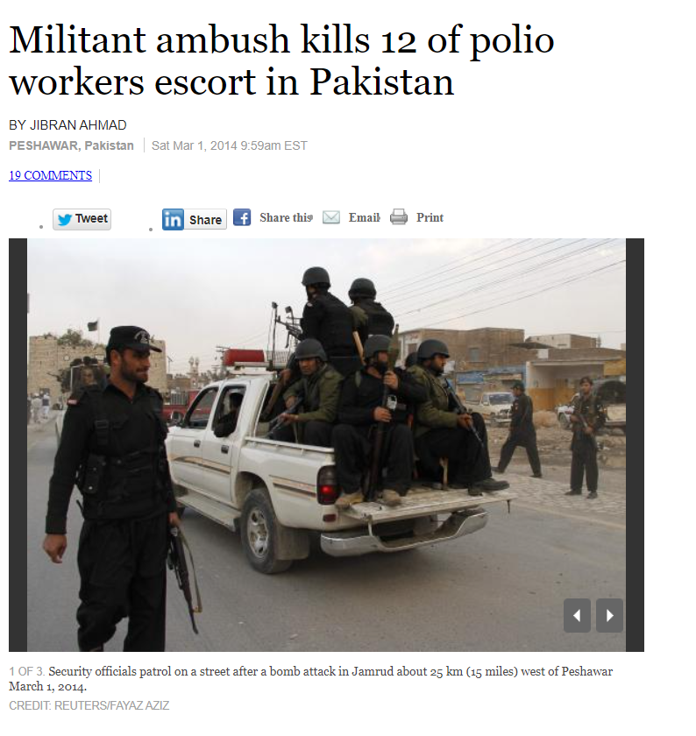

[Reuters o napadení konvoje s vakcínou](https://web.archive.org/web/20140301165222/http:/www.reuters.com/article/2014/03/01/us-pakistan-polio-attack-idUSBREA200AA20140301)

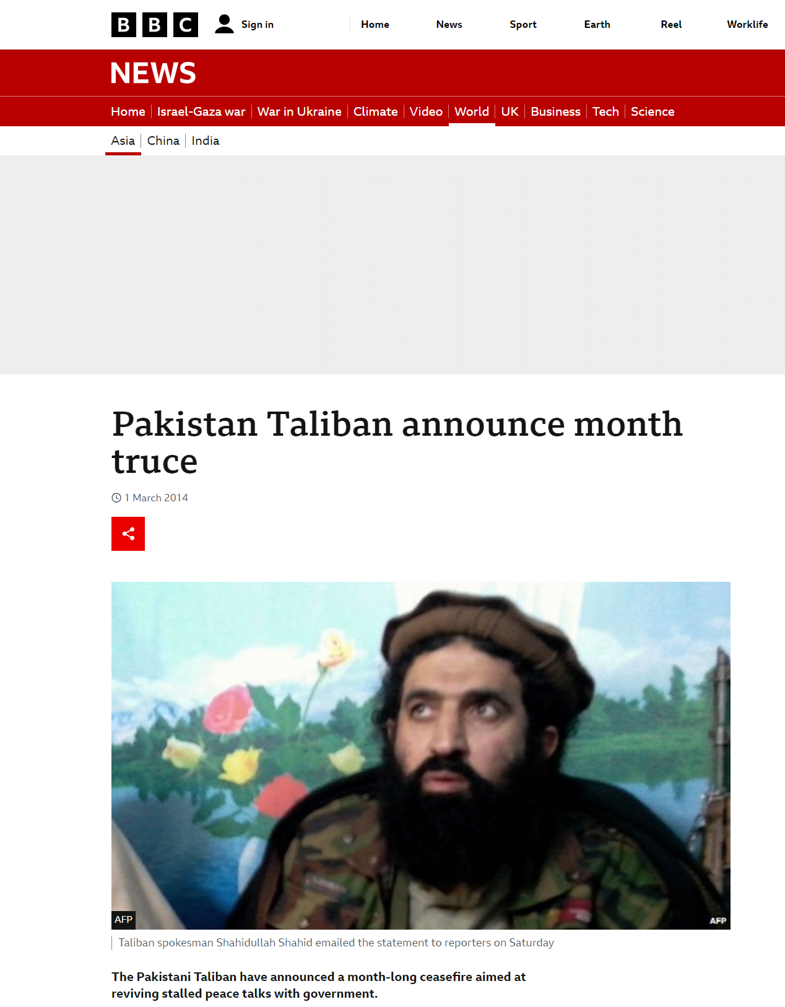

[BBC o příměří mezi vládou a extremisty](https://www.bbc.com/news/world-asia-26398758#TWEET1059152)

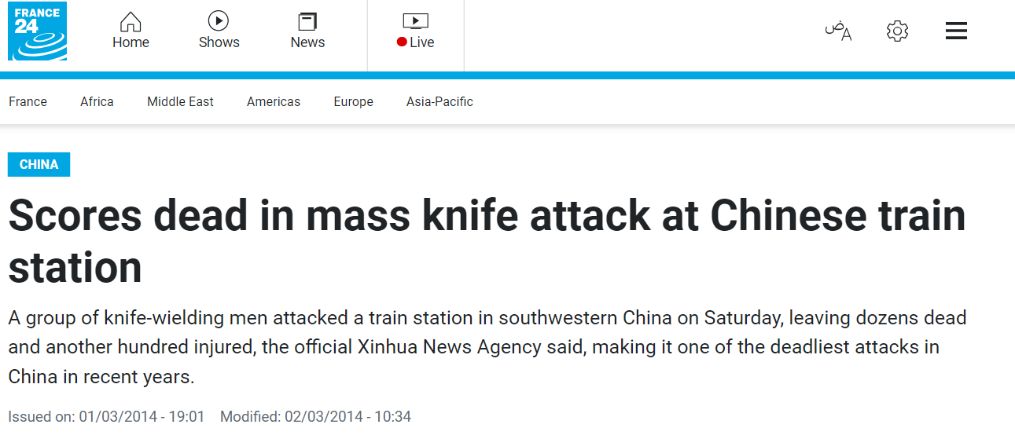

[France 24 o teroristickém útoku v Kunmingu](https://www.france24.com/en/20140301-china-knife-attack-train-station-kunming)

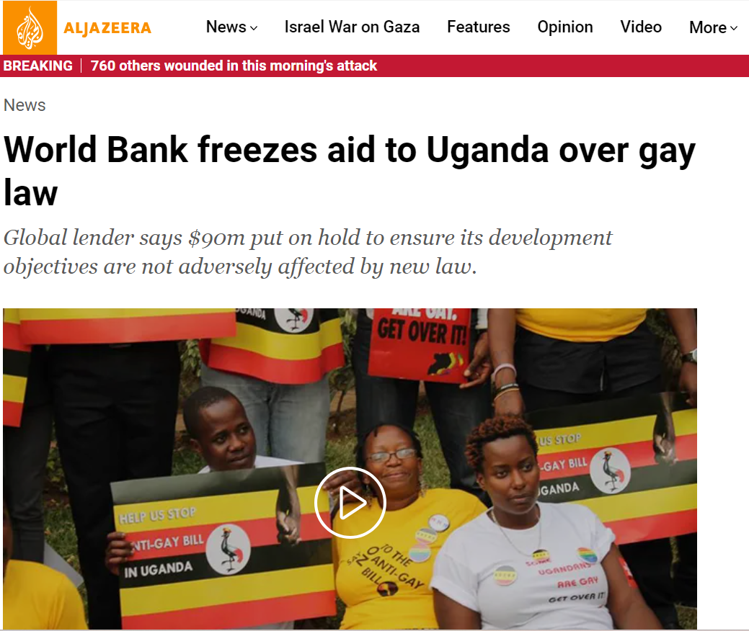

[Al Jazeera o zásahu Světové banky proti Ugandě](https://www.aljazeera.com/news/2014/2/28/world-bank-freezes-aid-to-uganda-over-gay-law)

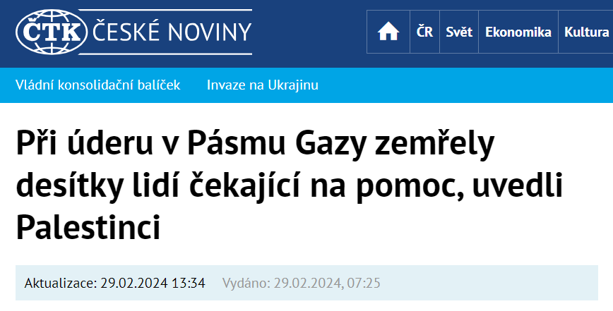

[ČTK o obětech v Gaze](https://www.ceskenoviny.cz/zpravy/v-pasmu-gazy-zemrelo-kvuli-valce-s-izraelem-uz-pres-30000-lidi-tvrdi-hamas/2486064)

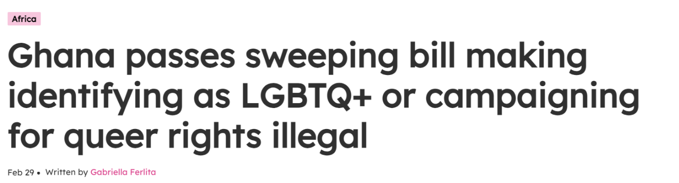

[Pink News o situaci lgbtq práv v Ghaně](https://www.thepinknews.com/2024/02/29/ghana-passes-anti-lgbt-bill/)

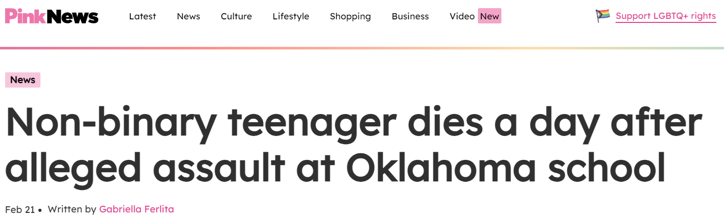

[Pink News o smrti Nexe Benedicta](https://www.thepinknews.com/2024/02/21/student-dies-at-school-oklahoma/)